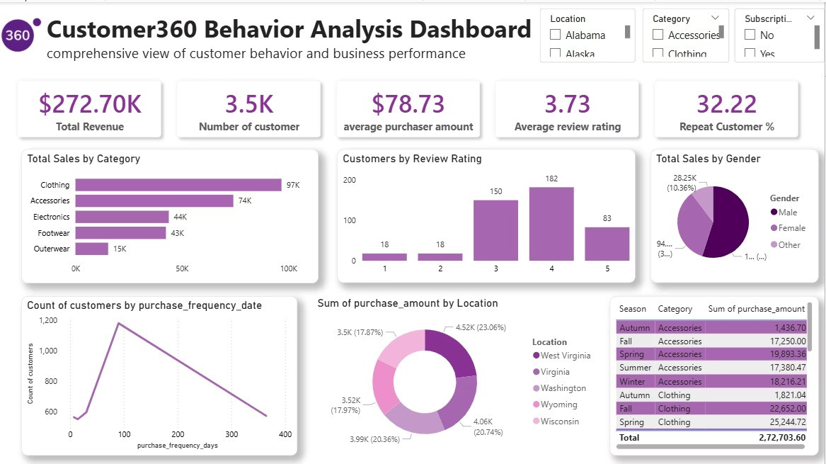

DATA ANALYTICS PROJECT
Customer360 Behavior Analysis
Data-Driven Customer Insights & Business Performance Analysis
Purchasing Behavior
Customer Satisfaction
Repeat Customers
Business Performance
OVERVIEW
Project Overview
This project analyzes customer behavior data to uncover sales trends, purchasing patterns, and business opportunities

enabling smarter, data-driven decisions.
Purchasing Behavior
Analyze how customers browse, select, and purchase

products.
Sales Performance
Understand revenue trends and high-performing categories.
Repeat Customers
Identify retention patterns and loyal customer segments.
Business Decisions
Translate data insights into actionable business strategies.

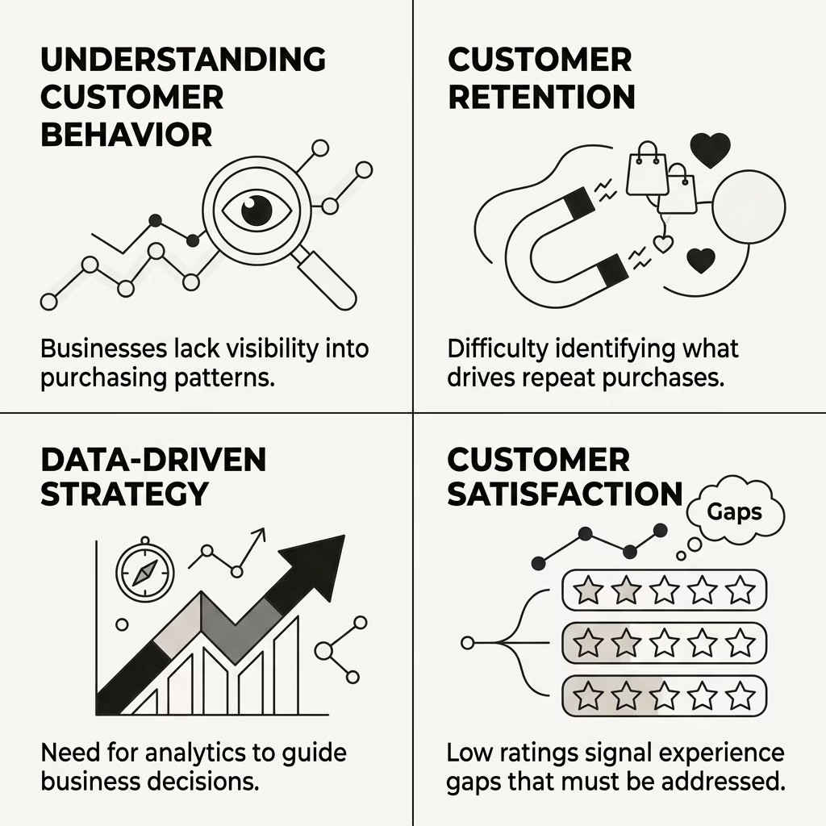
CHALLENGE
Problem Statement
Businesses face critical gaps in understanding customer behavior making it difficult to retain customers, improve satisfaction,
and drive growth.
Why This Matters
Without clear customer insights, businesses miss
opportunities to improve retention, increase revenue, and
enhance the overall customer experience.
Data analytics bridges the gap between raw
customer data and strategic business action.

TECH STACK
Tools & Technologies
A modern analytics stack combining Python, SQL, and Power BI for end-to-end data analysis and visualization.
Python
Pandas · NumPy · Matplotlib
SQL
Business analysis & data querying
Power BI
Interactive dashboards & reporting
Jupyter Notebook
Exploratory analysis environment
METHODOLOGY
Project Workflow
A structured five-phase approach transforms raw customer data into actionable business recommendations.
Data Cleaning
Prepare and validate raw datasets
EDA
Explore patterns and trends
SQL Analysis
Query business metrics
Dashboard Dev
Build interactive reports
Insights
Deliver recommendations
KPIS
Dashboard Summary
Key performance indicators from the Customer360 analysis covering 3.5K customers and $272.70K in total revenue.
$272.70K
Total Revenue
Generated across all categories
3.5
K
Customers Analyzed
Full customer base coverage
$78.73
Avg. Purchase
Per transaction value
3.73
Avg. Review Rating
Out of 5 stars
32.22
%
Repeat Customer Rate
Returning customer share

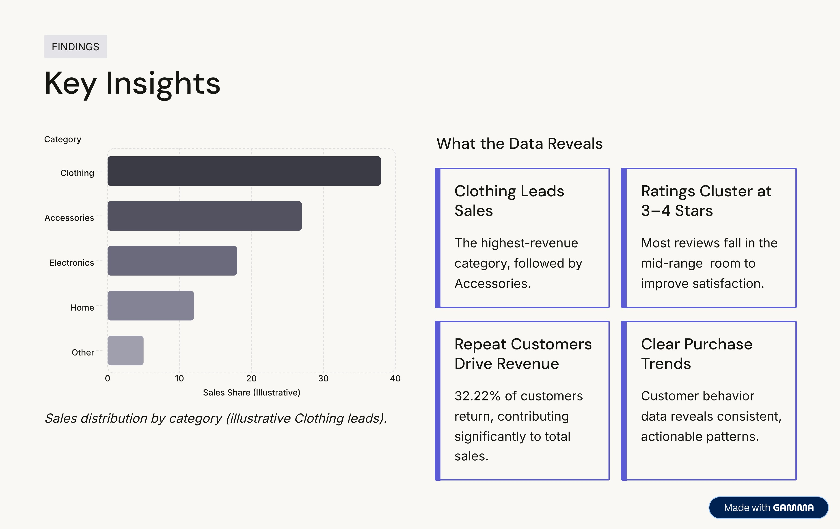


STRATEGY
Business Recommendations
Five targeted actions to improve performance, retention, and customer satisfaction.
1
Focus on High Performers
Invest in Clothing and Accessories — the top revenue drivers.
2
Strengthen Retention
Build loyalty programs to grow the 32.22% repeat customer base.
3
Elevate Satisfaction
Analyze low ratings to identify and fix pain points.
4
Targeted Marketing
Leverage behavior insights for personalized campaigns.
5
Improve Low-Rated Experiences
Address negative feedback to boost overall satisfaction.

SUMMARY
Conclusion
"This project demonstrates how data analytics transforms customer data into actionable business insights for smarter and

more effective business decisions."
Analyzed
3.5
K customers & $272.70K

revenue
Discovered
Purchase trends, ratings & retention

patterns
Delivered
5
strategic business

recommendations
Thank You
Customer360 Behavior Analysis
Shahbaz khan

